**TASK PLAN**

**Library Management System**

The library management system is a software to manage the manual functions of a library. The software helps to manage the entire library operations from maintaining book records to issue a book. In addition, it allows streamlined management of fine details of books such as author name, edition, and many other important details. So, it is easier to search for books and find the right materials for students and the librarian.

Electronic management via the software is essential to track information like issue date, due date, who has borrowed any material, etc. The system is developed and designed with an aim to facilitate efficient management of the schools to manage a modern library with accurate data management.

**Components of a Library Management System**

In order to maintain library management software, you will have the following set of components. These components are efficient to manage library operations accurately.

**Admin:** the administrators can access the entire functionality of the system via this component. The admin can maintain the records and track them as necessary. Also, the admin can add or remove entries into the system respectively.

**Reader:** the students who want to access library materials must do registration first. The registration allows for maintaining records accurately. After registering, they can check out and check in the library material.

**Book:** The admin can add new books or other materials to the system with the essential details. Each book has authno, isbn number, title, edition, category, PublisherID and price.

**Publisher:** The publisher has PublisherId, Year of publication and name.

**Report:** It has UserId, Reg_no, Book_no and Issue/Return date. Admin can view the issued materials with their due date.  And, if any book is overdue, the system will allow calculating fine for the same.

**Relation**

* Book(authno, isbn number, title, edition, category, PublisherID, price)
* Reader(UserId, Email, address, phone no, name)
* Publisher(PublisherId, Year of publication, name)
* Report( UserId, Reg_no, Book_no, Issue/Return date)
* Admin (LoginId, password)

**TASK 1: Conceptual Design through FTR** **CO1, S3**

(Tool: Creately/ERD Plus ,ALM:Think pair share)

Using basic database design methodology and ER modeler, design Entity Relationship

Diagram by satisfying the following sub tasks:

**1. a** Identifying the entities.

**1. b** Identifying the attributes.

**Sample Output**

* Publisher(PublisherId, Year of publication, name)
* Admin(LoginId, password, name, staff_id)
* Report( UserId, Reg_no, Book_no, Issue/Return date)
* Book(authno, isbn number, title, edition, category, PublisherID, price)
* Name is composite attribute of firstname and lastname.
* Phone no is multi valued attribute.
* Reader(UserId, Email, address, phone no, name)
* **c** Identification of relationships, cardinality, type of relationship.

**Sample Output**

* A reader can reserve N books but one book can be reserved by only one reader. The relationship 1:N.
* A publisher can publish many books but a book is published by only one publisher. The relationship 1:N.
* Admin keeps track of readers. The relationship is M:N.
* Admin maintains multiple reports. The relationship 1:N.
* Admin maintains multiple Books. The relationship 1:N.
* Admin provides login to multiple staffs. The relation is 1:N.
* **d** Reframing the relations with keys and constraint.

**Sample Output**

* {isbn number} is the Primary Key for Book Entity.
* {authno, isbn number, title} – Super key of Book entity.
* {PublisherId} is the foreign key of Book entity.
* {authno,title} – Candidate key of Book entity.
* UserId is the Primary Key for Readers entity.
* PublisherID is the Primary Key for Publisher entity
* LoginID as Primary Key for Authentication system entity.
* Reg_no is the Primary Key of reports entity.

**1. e** Using creately, develop ER diagram.

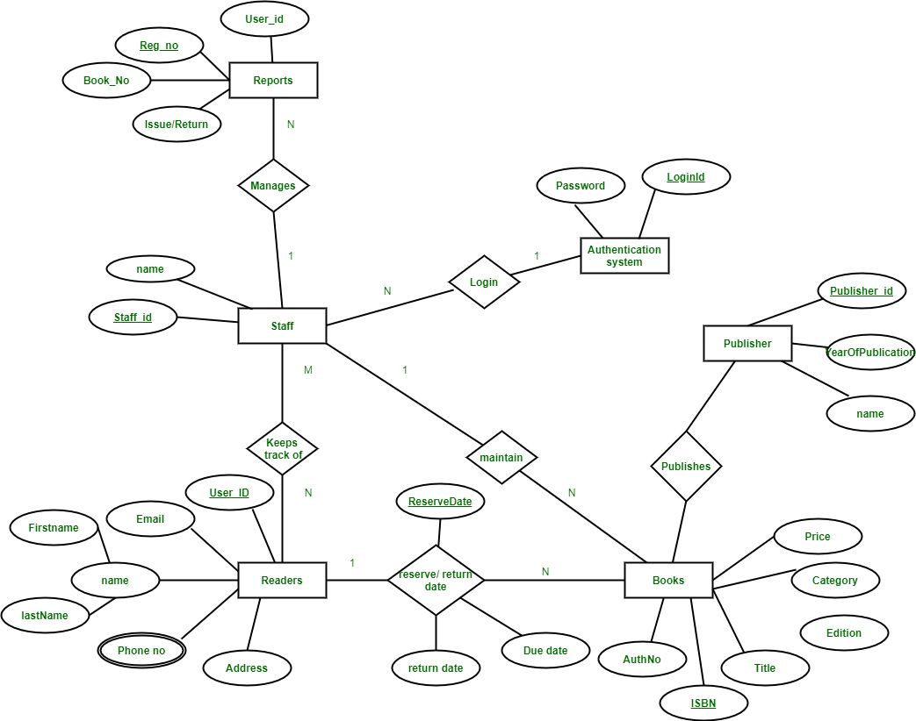

**TASK 2: Generating design of other traditional database model CO1, S3**

(Tool: Creately, ALM:Mind map)

Creating Hierarchical /Network model of the database by enhancing the sound abstract data by performing following tasks using forms of inheritance:

**2. a** Identify the specificity of each relationship, find and form surplus relations.

**2.b** Check is-a hierarchy/ has-a hierarchy and performs generalization and/or specialization relationship.

**2. c** Find the domain of the attribute and perform check constraint to the applicable.

**2. d** Rename the relations.

**2. e** Perform SQL Relations using DDL, DCL commands.

* Create all relations using DDL comments
* Alter the table Reader by adding email_id as a field.

**Sample output**

Syntax: Alter table reader add emailed varchar(20);

Output: Table altered

* Retrieve all the books under the category dbms.
* COMMIT the table after inserting values
* Rollback the table.

**TASK 3:Using Clauses, Operators and Functions in queries: CO2, S3**

**(**Tool: SQL/ Oracle, ALM:Fish bowl)

Perform the query processing on databases for different retrieval results of queries using DML, DRL operations using aggregate, date, string, indent functions, set clauses and operators.

* Retrieve all the author who wrote in dbms.
* Retrieve total number of books offered in the category program core
* Retrieve all authno and name who published books after 2000
* Retrieve readers name end with letter ‘a’
* Retrieve number of readers studied in each department.

**Sample Output:**

ECE 800

CSE 850

EEE 1000

* Retrieve all the female readers
* Retrieve all the staff who came library yesterday.

**TASK 4: Writing Sub Queries and Join Queries: CO2, S3**

**(**Tool: SQL/ Oracle, ALM: Fish bowl)

Perform the advanced query processing and test its heuristics using designing of optimal correlated and nested sub queries such as finding summary statistics.

* Retrieve isbnnumber ,authnumber and title of the books published under the course DBMS
* Retrieve reader name,id,dept id,department who studied in department CSE .
* Retrieve number of staff borrowed from each category of course
* Retrieve publisher id, year, name of the book published under the course OS.
* Retreive all the author name who are all published more than 30 books in the year 2022.
* Retrieve all the male readers name and their emailid

**Sample input**:

<refer reader, emailid)

**Sample output**:

name emailid

Rahul [jeni@gmail.com](mailto:jeni@gmail.com)

**TASK 5:** **Design Datalog query and recursive queries**(Tool: SQL/ Oracle) **CO2, S2**

Make use of Datalog query designing and recursive query for student registered for a course.

Find the prerequisite of object-oriented software engineering using recursive query

**Sample input:**

WITH RECURSIVE

Coursename(pre1, pre2) AS

(

(SELECT cname, pre-sub FROM pre_requisites)

UNION

(SELECT a1.pre1, a2.pre2

FROM coursename a1, Ancestor a2

WHERE a1.pre2 = a2.pre1)

)

SELECT pre1

FROM Ancestor

WHERE pre2= 'OOSE';

**Sample output:**

PROBLEM SOLVING USING C

**TASK 6: Procedures, Function and Loops**: **CO3, S3**

(Tool: SQL/ Oracle)

Programming using PL/SQL Procedures, Functions and loops on Number theory and business scenarios like.

* Write PL/SQL procedure using while loop, printing prime numbers in a range given.
* Write PL/SQL function recursion for factorial finding and calculate nth term.
* Write PL/SQL block without procedure/function to print all even multiples of 4,8 and not of 32 below 500.
* Write a non-recursive procedure for palindrome checking.

**Sample input:**

Enter input: madam

**Sample output:**

Madam is Palindrome

* Write a simple loop program to print 1 2 3 vertically using PL/SQL loop

**TASK 7**: **Triggers, Views and Exceptions** (Tool: SQL/ Oracle)**CO3, S3**

Conduct events, views, exceptions on CRUD operations for restricting phenomenon

* Create a simple trigger before insert or update or delete trigger in student table

**Sample input:**

<refer user schema>

**Sample output:**

S_id is inserted successfully

* Create a view of all readers name and emaiid who are currently in fourth semester.

**Sample input:**

<refer reader schema>

create trigger book_copies_deducts

after INSERT

on book_issue

for each row

update book_det set copies = copies - 1 where bid = new.bid;

**Sample output:**

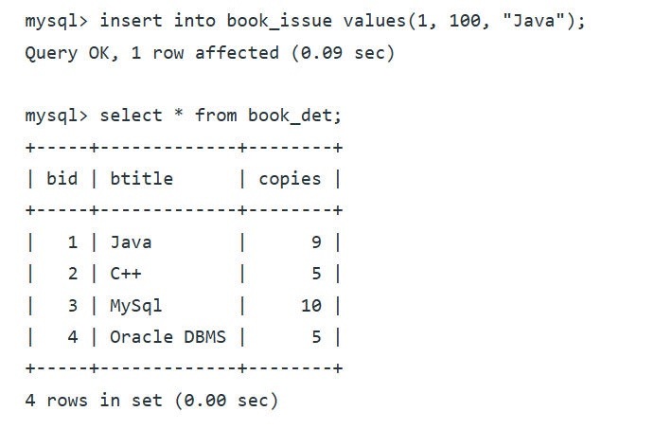

* Raise an exceptional handling whenever a user tries to identify publisherid that does not exists from Publisher Table.

**TASK 8**: **CRUD operations in Document databases** (Tool: MongoDB ) **CO3, S3**

Perform Mongoose using NPM design on MongoDB designing document database and performing CRUD operations like creating, inserting, querying, finding, removing operations.

Perform the following tasks of library databases.

* Design mongoDB collection for students
* Insert single student detail at a time

**Sample input/output:**

* Db,student.insertOne({s_id:VTU12345”,Name:”Stephen”,year:”3”,dept_id:”101”,contact no,”9876543210” },
* 1 document inserted
* Db.book.find().pretty();
* Insert multiple students at a time
* Insert all at a time.
* Find students who enrolled Java
* Find coursename which is registered by most number of students
* Delete single student record at a time
* Delete multiple student at a time
* Delete all student at a time who are all registered more than
* Update Faculty at a time who is taken single course
* Update multiple faculty at a time who are all handled compiler design
* Update all faculty at a time

**TASK 9:** **CRUD operations in Graph databases** (Tool:Neo4j) **CO3, S3**

Perform GraphQL/Neo4j graph space design for recommendation engines. Also perform CRUD operations like creating, inserting, querying, finding, deleting operations on graph spaces.

* Create a graph database for different categories of courses offered by the department and their pre-requisites
* Create a node for prerequisites

**Sample input:**

Create (pr: pre-requisites

{ ccode:123, cname:"DBMS",pre_id:"12345",pre_sub: “DS”

}

)

* Insert a course details in each course category
* Delete a course enrolled by student if not satisfied the prerequesites

**TASK 10: Normalizing databases using functional dependencies upto BCNF CO1, S2**

(Tool: GU/ Table Normalization Tool, ALM:Learning by doing)

Upon relational tables created in task-2, perform normalization up to BCNF based on given Dependencies as following for the assumed relations specified:

**Sample input**

* Book(authno, isbn number, title, edition, category, PublisherID, price)
* Reader(UserId, Email, address, phone no, name)
* Publisher(PublisherId, Year of publication, name)
* Admin(LoginId, password, name, staff_id)
* Report( UserId, Reg_no, Book_no, Issue/Return date)

Isbn number authno,title,publisher id

Isbn number edition,category

Isbn number authno

useridname,contactno,

userid name

PublisherId coursename,credits,category

LoginId name, staff_id

LoginId staff_id

**3. a** Apply the functional dependency, normalize to 1NF

**3. b** Normalize the relations using FD+ and α+

**3. c** Find the minimal cover, canonical cover.

**3. d** Normalize to 2NF, add/alter constraints if necessary.

**3. e** Normalize to BCNF, add/alter constraints if necessary.

**3. f** Normalize to 3NF, add/alter constraints if necessary.

**3. g** Perform SQL Relational operations using simple DML queries.

**Sample output**

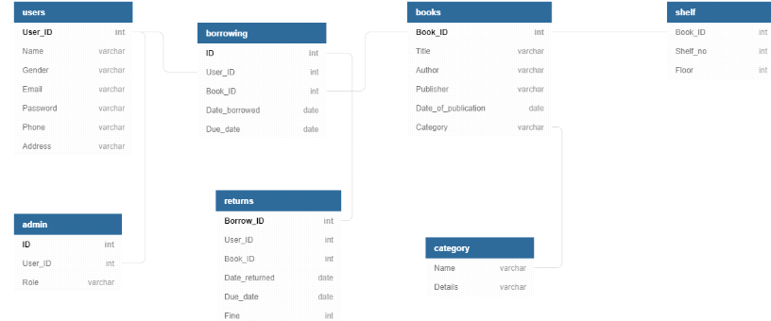

**TASK 11**: **Menus, Forms and Reports: CO4, S3**

(Tool: SQL/ Oracle 11g ,ALM:Pick the winner)

For an application, creating and debugging Menus, Forms and reports using Oracle Forms and Report Builder,make a report of students with their details.

**Sample input:**

Make a report of students with their details

**Sample output:**

**s_id s_name year dept_id dob gender place phone_no email_id**

1234 TEJA 3 301 17/08/2001 M Chennai 9876543210 [xyz@gmail.com](mailto:xyz@gmail.com)

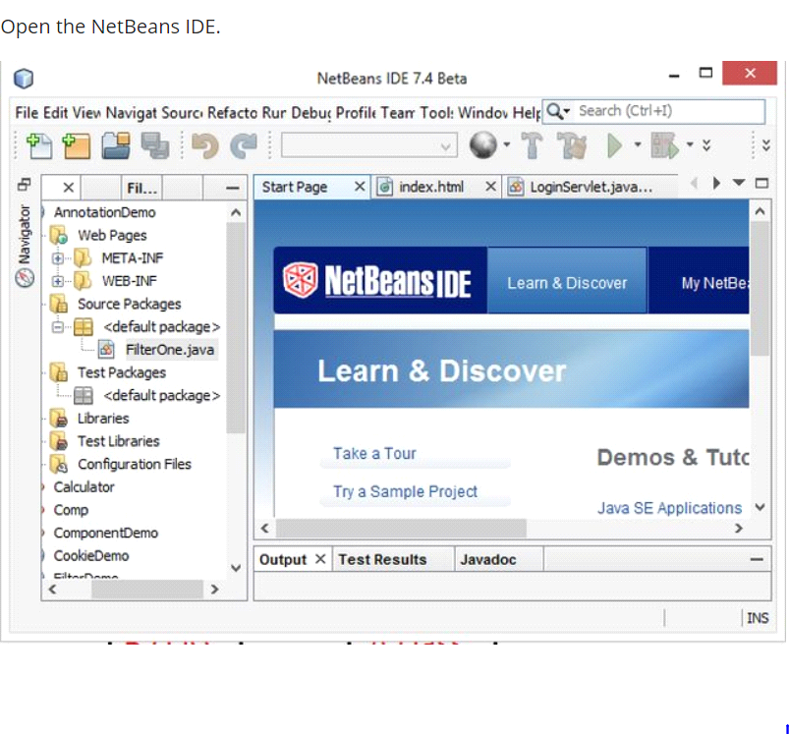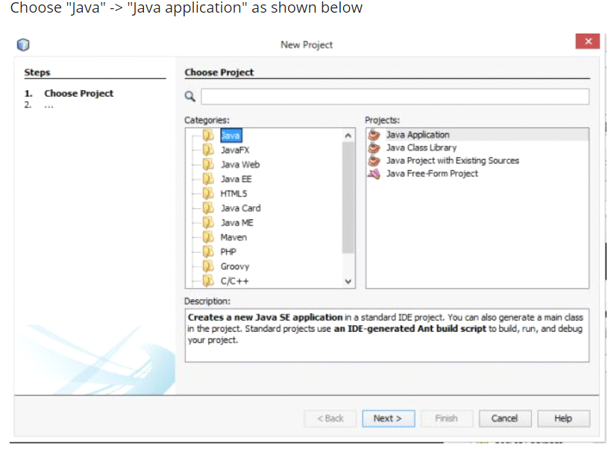

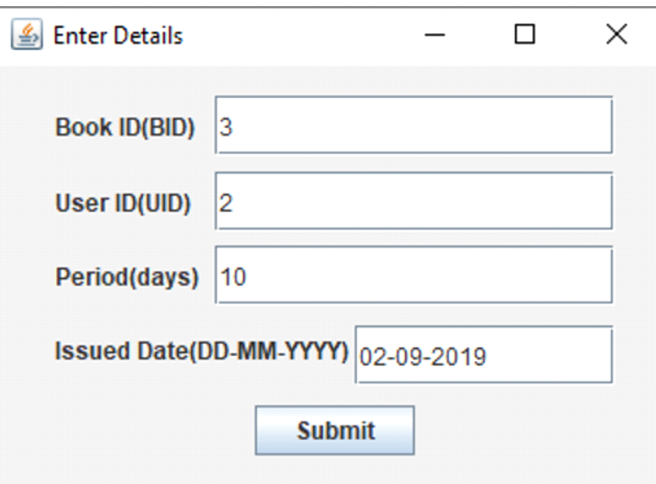

**TASK 12:** **Micro Project CO5, S3**

(Tool: Oracle SQL/ SQL Developer/MySQL/MongoDB/NetBeans)

Develop Micro project based on business case scenario on use cases specified in Part-II.

**Part-II**

**\*\***In perusal to the above task, Every student shall select and incorporate for one of the following use cases for Task-12**.**

**Use case-1: User Module.**

**This module is further divided into various sub-modules describing the user in a better way:**

* **New user register:**
* To sign up a new user to this system.
* **Student Login:**
* So as to confirm that only an authenticated user is using the project.
* **Search book:**
* The user can search book based on book id, book name, or by author name.
* **Issue Book:**
* To help the user get the required books issued.
* **Return Book:**
* To return the book before the last date without fine, or after the specified time duration with a late fine.

**Use case-2: Admin Module**

It is to be operated by the admin with a unique id and password. The admin is the person who decides authentication and authorization for all the different users of the application.

**It further can be subdivided as:**

* Register user.
* Issue Book.
* Maintain books in a stack, which means record the availability at a regular time interval.

**Use case-3: Librarian Module**

Includes all the library staff who are required to enter the records in the system and keep an eye on the various activities like the issue of the book, the return of the book, non-availability of books, etc. through the developed system.

**TASK 1 - CONCEPTUAL DESIGN THROUGH FTR**

**Aim**

To identify entities attributes and relationship from the usecase given and to draw the ER Diagram for the same.

**Tasks and sample output**

Using basic database design methodology and ER modeler, design Entity Relationship

Diagram of library management system.

**1. a. Identifying the entities.**

**1. b. Identifying the attributes.**

**Sample Output**

* Publisher(PublisherId, Year of publication, name)
* Admin(LoginId, password, name, staff_id)
* Report( UserId, Reg_no, Book_no, Issue/Return date)
* Book(authno, isbn number, title, edition, category, PublisherID, price)
* Name is composite attribute of firstname and lastname.
* Phone no is multi valued attribute.
* Reader(UserId, Email, address, phone no, name)

**2. Identification of relationships, cardinality and type of relationship.**

**Sample Output**

* A reader can reserve N books but one book can be reserved by only one reader. The relationship 1:N.
* A publisher can publish many books but a book is published by only one publisher. The relationship 1:N.
* Admin keeps track of readers. The relationship is M:N.
* Admin maintains multiple reports. The relationship 1:N.
* Admin maintains multiple Books. The relationship 1:N.
* Admin provides login to multiple staffs. The relation is 1:N.

**3. Reframing the relations with keys and constraint.**

**Sample Output**

* {isbn number} is the Primary Key for Book Entity.
* {authno, isbn number, title} – Super key of Book entity.
* {PublisherId} is the foreign key of Book entity.
* {authno,title} – Candidate key of Book entity.
* UserId is the Primary Key for Readers entity.
* PublisherID is the Primary Key for Publisher entity
* LoginID as Primary Key for Authentication system entity.
* Reg_no is the Primary Key of reports entity.

**Using creately, develop ER diagram.**



**RESULT**: The task to create an E-R diagram of library management system is executed successfully.

**TASK 2 - GENERATING DESIGN OF OTHER TRADITIONAL DATABASE MODEL**

**Title:** Implementation of DDL commands of SQL with suitable examples.

* Create table
* Alter table
* Drop Table

**Objective**

To understand the different issues involved in the design and implementation of a database system

**Theory**

Oracle has many tools such as SQL * PLUS, Oracle Forms, Oracle Report Writer, Oracle Graphics etc SQL * PLUS

.The SQL * PLUS tool is made up of two distinct parts. These are

* **Interactive SQL**: Interactive SQL is designed for create, access and manipulate data structures like tables and indexes.
* **PL/SQL:** PL/SQL can be used to developed programs for different applications.
* **Oracle Forms**: This tool allows you to create a data entry screen along with the suitable menu objects. Thus it is the oracle forms tool that handles data gathering and data validation in a commercial application.
* **Report Writer:** Report writer allows programmers to prepare innovative reports using data from the oracle structures like tables, views etc. It is the report writer tool that handles the reporting section of commercial application.
* **Oracle Graphics:** Some of the data can be better represented in the form of pictures. The oracle graphics tool allows programmers to prepare graphs using data from oracle structures like tables, views etc.

**SQL (Structured Query Language):**

Structured Query Language is a database computer language designed for managing data in relational database management systems (RDBMS), and originally based upon Relational Algebra. Its scope includes data query and update, schema creation and modification, and data access control.

SQL was one of the first languages for Edgar F. Codd's relational model and became the most widely used language for relational databases.

* IBM developed SQL in mid of 1970’s.
* Oracle incorporated in the year 1979.
* SQL used by IBM/DB2 and DS Database Systems.
* SQL adopted as standard language for RDBS by ASNI in 1989.

**DATA TYPES**

* **CHAR (Size):** This data type is used to store character strings values of fixed length. The size in brackets determines the number of characters the cell can hold. The maximum number of character is 255 characters.
* **VARCHAR (Size) / VARCHAR2 (Size):** This data type is used to store variable length alphanumeric data. The maximum character can hold is 2000 character.
* **NUMBER (P, S):** The NUMBER data type is used to store number (fixed or floating point). Number of virtually any magnitude may be stored up to 38 digits of precision. Number as large as 9.99 * 10 124. The precision (p) determines the number of places to the right of the decimal. If scale is omitted then the default is zero. If precision is omitted, values are stored with their original precision up to the maximum of 38 digits.
* **DATE**: This data type is used to represent date and time. The standard format is DD- MM-YY as in 17- SEP-2009. To enter dates other than the standard format, use the appropriate functions. Date time stores date in the 24-Hours format. By default the time in a date field is 12:00:00 am, if no time portion is specified. The default date for a date field is the first day the current month.
* **LONG:** This data type is used to store variable length character strings containing up to 2GB. Long data can be used to store arrays of binary data in ASCII format. LONG values cannot be indexed, and the normal character functions such as SUBSTR cannot be applied.
* **RAW:** The RAW data type is used to store binary data, such as digitized picture or image. Data loaded into columns of these data types are stored without any further conversion. RAW data type can have a maximum length of 255 bytes. LONG RAW data type can contain up to 2GB.

**SQL language is sub-divided into several language elements, including:**

* **Clauses**, which are in some cases optional, constituent components of statements and queries.
* **Expressions**, which can produce either scalar values or tables consisting of columns and rows of data.
* **Predicates** which specify conditions that can be evaluated to SQL three-valued logic (3VL) Boolean truth values and which are used to limit the effects of statements and queries, or to change program flow.
* **Queries** which retrieve data based on specific criteria.
* **Statements** which may have a persistent effect on schemas and data, or which may control transactions, program flow, connections, sessions, or diagnostics.
* SQL statements also include the **semicolon** (";") statement terminator. Though not required on every platform, it is defined as a standard part of the SQL grammar.
* **Insignificant white space** is generally ignored in SQL statements and queries, making it easier to format SQL code for readability.

There are five types of SQL statements. They are:

* DATA DEFINITION LANGUAGE (DDL)
* DATA MANIPULATION LANGUAGE (DML)
* DATA RETRIEVAL LANGUAGE (DRL)
* TRANSATIONAL CONTROL LANGUAGE (TCL)
* DATA CONTROL LANGUAGE (DCL)

1.**DATA DEFINITION LANGUAGE (DDL):** The Data Definition Language (DDL) is used to create and destroy databases and database objects. These commands will primarily be used by database administrators during the setup and removal phases of a database project. Let's take a look at the structure and usage of four basic DDL commands:

1. CREATE 2. ALTER 3. DROP 4. RENAME

* **CREATE**

(a) **CREATE TABLE**: This is used to create a new relation (table)

syntax: CREATE TABLE <relation_name/table_name > (field_1 data_type(size),field_2 data_type(size),);

**Example:**

create table member(membno int, name varchar(20), department varchar(20),gender varchar(10));

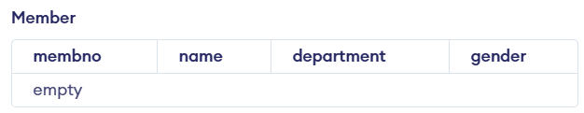

create table book(isbn int, title varchar(30), authors varchar(10),pagecount int, publisher varchar(10));

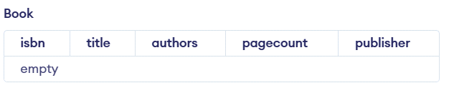

create table borrowed(membno int, isbn int, issuedate date);

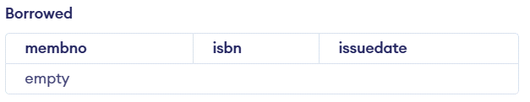

* **ALTER**
* **ALTER TABLE ...ADD**...: This is used to add some extra fields into existing relation.

**Syntax:** ALTER TABLE relation_name ADD (new field_1 data_type(size), new field_2 data_type(size),..);

**Example**: SQL>Alter table borrowed add name VARCHAR(10)

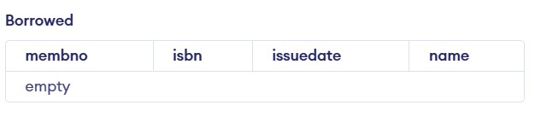

* **DROP TABLE**: This is used to delete the structure of a relation. It permanently deletes the records in the table.

**Syntax**: DROP TABLE relation_name;

**Example:** SQL>DROP TABLE borrowed;

* **RENAME:** It is used to modify the name of the existing database object. Syntax: RENAME TABLE old_relation_name TO new_relation_name;

Example: SQL> ALTER TABLE borrowed RENAME COLUMN name to membername;

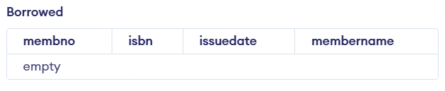

**RESULT**: The task to create, delete and alter the table are executed successfully.

**TASK 3 - USING CLAUSES, OPERATORS AND FUNCTIONS IN QUERIES**

**Title :** Implementation of DML commands using clauses, operators and functions in queries.

* Insert table
* Select table
* Update table
* Delete Table

**Objective :**

* To understand the different issues involved in the design and implementation of a database system

**Theory:**

**DATA MANIPULATION LANGUAGE (DML):** The Data Manipulation Language (DML) is used to retrieve, insert and modify database information. These commands will be used by all database users during the routine operation of the database. Let's take a brief look at the basic DML commands:

1. INSERT 2. UPDATE 3. DELETE

* **INSERT INTO:** This is used to add records into a relation. These are three type of INSERT INTO queries which are as
* **Inserting a single record**

**Syntax**: INSERT INTO < relation/table name> (field_1,field_2……field_n)VALUES (data_1,data_2,. data_n);

**Example**: SQL> insert into member values(116,'Shan','CSE','male');

Inserting a single record

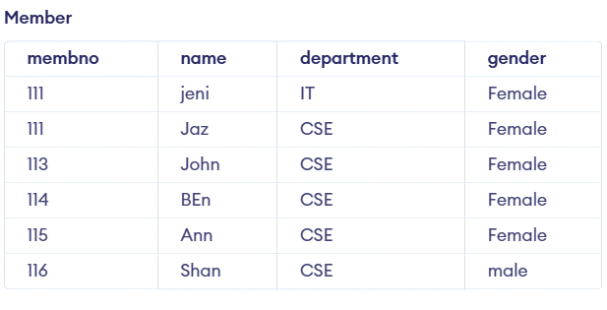

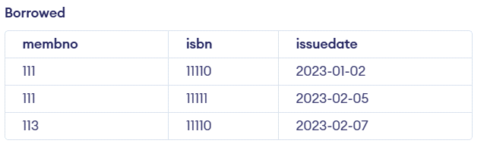

* **UPDATE-SET-WHERE**: This is used to update the content of a record in a relation.

**Syntax**: SQL>UPDATE relation name SET Field_name1=data,field_name2=data, WHERE field_name=data;

**Example**: SQL>UPDATE member SET sname = ‘kumar’ WHERE sno=1;

* **DELETE-FROM:** This is used to delete all the records of a relation but it will retain the structure of that relation.
* **DELETE-FROM**: This is used to delete all the records of relation.

**Syntax**:SQL>DELETE FROM relation_name;

**Example:** SQL>DELETE FROM std;

* **DELETE -FROM-WHERE**: This is used to delete a selected record from a relation.

**Syntax**: SQL>DELETE FROM relation_name WHERE condition;

**Example:** SQL>DELETE FROM student WHERE sno = 2;

5. **TRUNCATE**: This command will remove the data permanently. But structure will not be removed.

**Difference between Truncate & Delete**

By using truncate command data will be removed permanently & will not get back where as by using delete command data will be removed temporally & get back by using roll back command.

By using delete command data will be removed based on the condition where as by using truncate command there is no condition.

Truncate is a DDL command & delete is a DML command. **Syntax:** TRUNCATE TABLE <Table name> **Example:** TRUNCATE TABLE student;

**Sample Queries and Output**

* Retrieve member name end with letter ‘n’ and member no between 111 and 115.

**Query:**

SELECT first_name, last_name, salary FROM employees

WHERE first_name LIKE '%m';

Output:

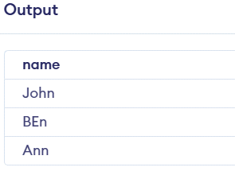

* List the books where pagecount between 700 and 800 – between clause, and operator.

**Query:**

select * from book where pagecount between 700 and 800;

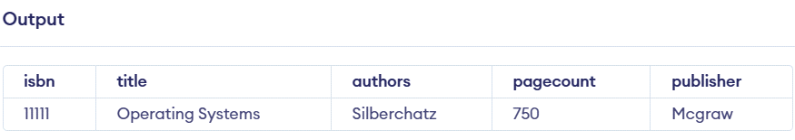

* Find the records who has minimum number of pagecount – Aggregate

**Query:**

select min(pagecount) from book;

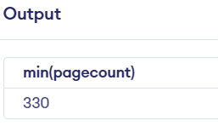

* Find the records whose issue date greater than or equal to 07-02-2023

**Query:**

select * from borrowed where issuedate >='2023-02-07';

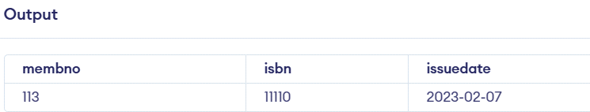

* List the membno, but the same membno are listed ones.

**Query:**

select distinct membno from member;

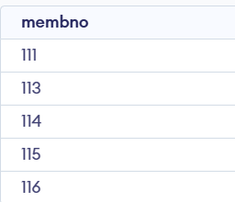

* Combine the rocords of member and book relation – Union

**Query:**

SELECT membno FROM member UNION SELECT membno FROM borrowed;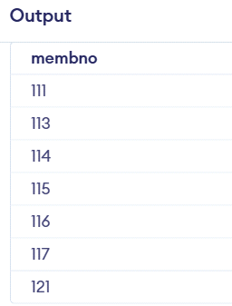

* Groupby the member number based on their gender and department.

**Query**

SELECT membno FROM member GROUP BY gender,department;

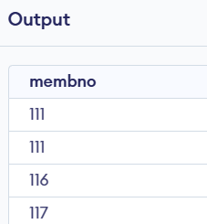

* Find the authors and their publication details using groupby and orderby clauses.

**Query**

SELECT authors,publisher, COUNT( * ) no FROM book GROUP BY authors, publisher order by authors

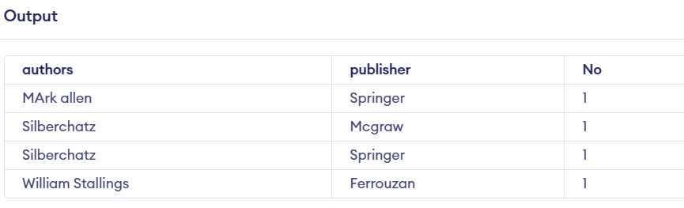

**RESULT**: The task to implement the DML commands are executed successfully.

**TASK 4 - USING FUNCTIONS IN QUERIES AND WRITING SUBQUERIES**

* A Subquery or Inner query or a Nested query is a query within another SQL query and embedded within the WHERE clause.
* A subquery is used to return data that will be used in the main query as a condition to further restrict the data to be retrieved.
* Subqueries can be used with the SELECT, INSERT, UPDATE, and DELETE statements along with the operators like =, <, >, >=, <=, IN, BETWEEN, etc.

There are a few rules that subqueries must follow −

* Subqueries must be enclosed within parentheses.
* A subquery can have only one column in the SELECT clause, unless multiple columns are in the main query for the subquery to compare its selected columns.
* An ORDER BY command cannot be used in a subquery, although the main query can use an ORDER BY. The GROUP BY command can be used to perform the same function as the ORDER BY in a subquery.
* Subqueries that return more than one row can only be used with multiple value operators such as the IN operator.
* The SELECT list cannot include any references to values that evaluate to a BLOB, ARRAY, CLOB, or NCLOB.
* A subquery cannot be immediately enclosed in a set function.
* The BETWEEN operator cannot be used with a subquery. However, the BETWEEN operator can be used within the subquery.

**Subqueries with the SELECT Statement**

Syntax:

SELECT column_name [, column_name ]

FROM table1 [, table2 ]

WHERE column_name OPERATOR

(SELECT column_name [, column_name ]

FROM table1 [, table2 ]

[WHERE])

* **Write the subqueries to display the isbn number for the records whose page count is less than 500.**

SELECT *

FROM book

WHERE isbn IN (SELECT isbn

FROM book

WHERE pagecount > 500) ;

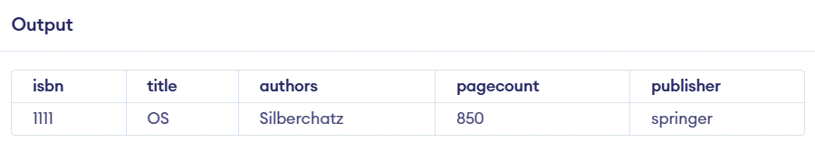

* **Select the title and authors whose pagecount is minimum using subquery and functions.**

Query

SELECT title,authors FROM book

WHERE pagecount = (SELECT MIN(pagecount) FROM book)

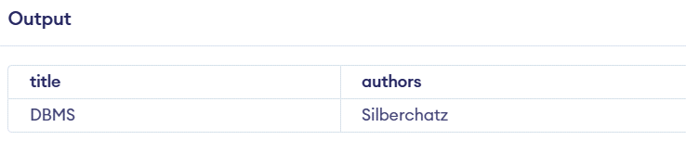

* **Write a subquery to return the values from multiple tables.**

Query

SELECT name, department FROM member WHERE membno == (SELECT isbn FROM book)

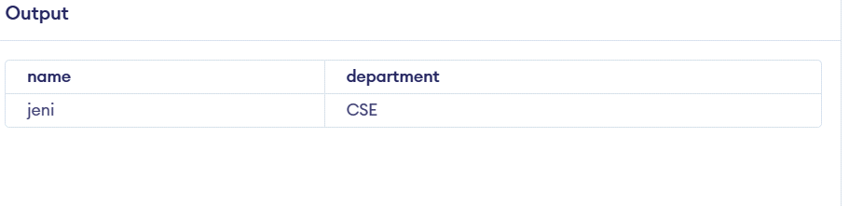

**Subqueries with the INSERT Statement**

INSERT INTO table_name [ (column1 [, column2 ]) ]

SELECT [ *|column1 [, column2 ]

FROM table1 [, table2 ]

[ WHERE VALUE OPERATOR ]

* **Insert all records in book table into bookduplicate table.**

INSERT INTO bookduplicate

SELECT * FROM book

WHERE title IN (SELECT title

FROM book) ;

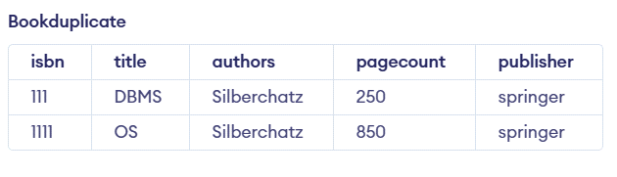

**Subqueries with the UPDATE Statement**

Syntax

UPDATE table

SET column_name = new_value

[ WHERE OPERATOR [ VALUE ]

(SELECT COLUMN_NAME

FROM TABLE_NAME)

[ WHERE) ]

* **updates pagecount by 2 times in the book table for all the customers whose pagecount is greater than or equal to 300.**

UPDATE book SET pagecount = pagecount * 2

WHERE title IN (SELECT title FROM bookduplicate WHERE pagecount <= 300 );

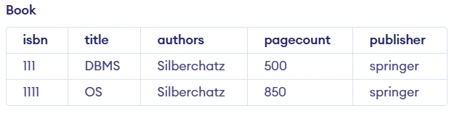

**Subqueries with the DELETE Statement**

DELETE FROM TABLE_NAME

[ WHERE OPERATOR [ VALUE ]

(SELECT COLUMN_NAME

FROM TABLE_NAME)

[ WHERE) ]

* **Deletes the records from the member table for all the members whose gender is equal to male.**

DELETE FROM member WHERE gender IN (SELECT gender FROM member WHERE gender == 'male' );

Output

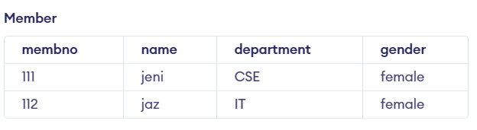

**RESULT**: The implementation of SQL commands using functions and subqueries is executed successfully.

**TASK 5 - WRITING JOIN QUERIES, EQUIVALENT, AND/OR RECURSIVE QUERIES**

**Title** : Implementation of different types of Joins and recursive queries.

* A SQL JOIN combines records from two tables.
* A JOIN locates related column values in the two tables.
* A query can contain zero, one, or multiple JOIN operations.
* INNER JOIN is the same as JOIN; the keyword INNER is optional.

**Aim:**

To implement and execute JOIN queries, equivalent queries, and recursive queries using a university database scenario.

Procedure:

The SQL Joins clause is used to combine records from two or more tables in a database. A JOIN is a means for combining fields from two tables by using values common to each. The join is actually performed by the ‘where’ clause which combines specified rows of tables

* Create the database and tables (Students, Departments, Courses, Enrollments).
* Insert sample data.
* Write SQL queries using different types of **JOINs**.
* Write **equivalent queries** (different approaches to get the same result).
* Implement a **recursive query** (using WITH RECURSIVE).
* Display results and verify correctness.

Step1:

**Syntax:**

SELECT column 1, column 2, column 3...FROM table_name1, table_name2 WHERE table_name1.column name = table_name2.columnname;

**Types of Joins :**

* Simple Join
* Self Join
* Outer Join

**Simple Join:**

It is the most common type of join. It retrieves the rows from 2 tables having a common column and is further classified into

**Equi-join :**

A join, which is based on equalities, is called equi-join.

**Example:**

Select * from item, cust where item.id=cust.id;

In the above statement, item-id = cust-id performs the join statement. It retrieves rows from both the tables provided they both have the same id as specified by the where clause. Since the where clause uses the comparison operator (=) to perform a join, it is said to be equijoin. It combines the matched rows of tables. It can be used as follows:

* To insert records in the target table.
* To create tables and insert records in this table.
* To update records in the target table.
* To create views.

**Non Equi-join:**

It specifies the relationship between columns belonging to different tables by making use of relational operators other than’=’.

**Example:**

Select * from item, cust where item.id<cust.id;

**Table Aliases**

Table aliases are used to make multiple table queries shorted and more readable. We give an alias name to the table in the ‘from’ clause and use it instead of the name throughout the query.

**Self join:**

Joining of a table to itself is known as self-join. It joins one row in a table to another.

It can compare each row of the table to itself and also with other rows of the same table.

**Example:**

select * from emp x ,emp y where x.salary >= (select avg(salary) from x.emp where x. deptno

=y.deptno);

**Outer Join:**

It extends the result of a simple join. An outer join returns all the rows returned by simple join as well as those rows from one table that do not match any row from the table. The symbol (+) represents outer join.

**Different Types of SQL JOINs**

Here are the different types of the JOINs in SQL:

* **(INNER) JOIN**: Returns records that have matching values in both tables SELECT column_name(s) FROM table1

INNER JOIN table2 ON table1.column_name = table2.column_name;

* **LEFT (OUTER) JOIN**: Return all records from the left table, and the matched records from the right table.

SELECT column_name(s) FROM table1

LEFT JOIN table2 ON table1.column_name = table2.column_name;

* **RIGHT (OUTER) JOIN**: Return all records from the right table, and the matched records from the left table.

SELECT column_name(s) FROM table1

RIGHT JOIN table2 ON table1.column_name = table2.column_name;

* **FULL (OUTER) JOIN**: Return all records when there is a match in either left or right table SELECT column_name(s) FROM table1

FULL OUTER JOIN table2 ON table1.column_name = table2.column_name;

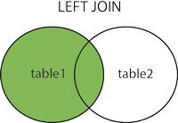 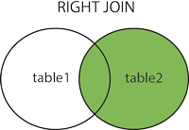

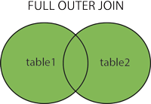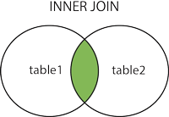

The SQL Joins clause is used to combine records from two or more tables in a database. A JOIN is a means for combining fields from two tables by using values common to each.

Consider the following two tables −

**Inner Join**

The INNER JOIN keyword selects all rows from both tables as long as the condition is satisfied. This keyword will create the result-set by combining all rows from both the tables where the condition satisfies.

Syntax

SELECT *column_name(s)*  
FROM *table1*  
INNER JOIN *table2*ON *table1.column_name*=*table2.column_name*;

Query

SELECT borrowed.membno, member.NAME FROM member

INNER JOIN borrowed

ON member.membno = borrowed.membno;

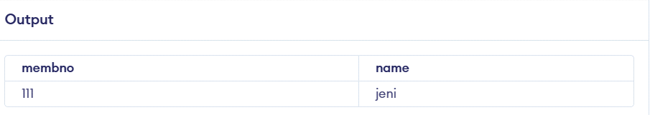

**Left Join**

The LEFT JOIN keyword returns all records from the left table (table1), and the matching records from the right table (table2).

Syntax

SELECT *column_name(s)*  
FROM *table1*  
LEFT JOIN *table2*ON *table1.column_name*=*table2.column_name*;

**Query**

SELECT member.NAME, borrowed.membno FROM member

LEFT JOIN borrowed ON borrowed.membno = member.membno;

**SQL RIGHT JOIN Keyword**

The RIGHT JOIN keyword returns all records from the right table (table2), and the matching records from the left table (table1).

Syntax

SELECT *column_name(s)*  
FROM *table1*  
RIGHT JOIN *table2*ON *table1.column_name*=*table2.column_name*;

**SQL FULL OUTER JOIN Keyword**

The FULL OUTER JOIN keyword returns all records when there is a match in left (table1) or right (table2) table records.

**Tip:** FULL OUTER JOIN and FULL JOIN are the same.

**Syntax :**

SELECT *column_name(s)*  
FROM *table1*  
FULL OUTER JOIN *table2*ON *table1.column_name*=*table2.column_name*WHERE *condition*;

**Recursive Queries**

Syntax

WITH RECURSIVE [cte_name] (column, ...) AS (

    [non-recursive_term]

    UNION ALL

    [recursive_term])

SELECT ... FROM [cte_name];

1 : Write a recursive query to create a Multiplication table by 2

WITH RECURSIVE x2 (result) AS (

    SELECT 1

    UNION ALL

    SELECT result*2 FROM x2)

SELECT * FROM x2 LIMIT 10;

Output

result

--------

1

2

4

8

16

32

64

128

256

512

(10 rows)

Example 2 - Write a recursive query to create a Fibonacci sequence.

WITH RECURSIVE fib(f1, f2) AS (

    SELECT 0, 1

    UNION ALL

    SELECT f2, (f1+f2) FROM fib )

SELECT f1 FROM fib LIMIT 10;

f1

----

0

1

1

2

3

5

8

13

21

34

(10 rows)

Result:

The implementation of SQL commands using Joins and recursive queries are executed successfully.

**Task -6**

**PL/SQL Procedures, functions, Loops**

**Aim:**

To implement PL/SQL Procedures, Functions and loops on Number theory and business scenarios.

**Procedure:**

PL/SQL is a combination of SQL along with the procedural features of programming languages. It was developed by Oracle Corporation in the early 90's to enhance the capabilities of SQL. PL/SQL is one of three key programming languages embedded in the Oracle Database, along with SQL itself and Java.

|  |  |
| --- | --- |
| **S.No** | **Sections & Description** |
| 1 | **Declarations**  This section starts with the keyword **DECLARE**. It is an optional section and defines all variables, cursors, subprograms, and other elements to be used in the program. |
| 2 | **Executable Commands**  This section is enclosed between the keywords **BEGIN** and **END** and it is a mandatory section. It consists of the executable PL/SQL statements of the program. It should have at least one executable line of code, which may be just a **NULL command** to indicate that nothing should be executed. |
| 3 | **Exception Handling**  This section starts with the keyword **EXCEPTION**. This optional section contains **exception(s)** that handle errors in the program. |

Simple program to print a sentence:

Syntax:

DECLARE

<declarations section>

BEGIN

<executable command(s)>

EXCEPTION

<exception handling>

END;

Program:

DECLARE

message varchar2(20):= 'booking closed';

BEGIN

dbms_output.put_line(message);

END;

Static input:

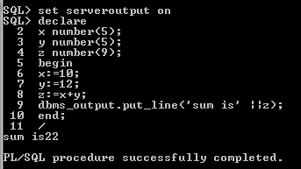

Dynamic Input:

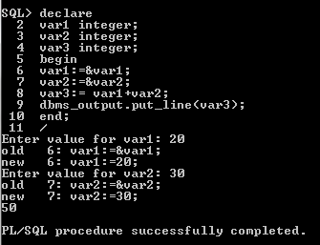

**DECLARE**

**hid number(3) := 100;**

**BEGIN**

**IF ( hid = 10 ) THEN**

**dbms_output.put_line('Value of hid is 10' );**

**ELSIF ( hid = 20 ) THEN**

**dbms_output.put_line('Value of hid is 20' );**

**ELSIF ( hid = 30 ) THEN**

**dbms_output.put_line('Value of hid is 30' );**

**ELSE**

**dbms_output.put_line('None of the values is matching');**

**END IF;**

**dbms_output.put_line('Exact value of hid is: '|| hid );**

**END;**

**/**

None of the values is matching

Exact value of hid is: 100

PL/SQL procedure successfully completed.

DECLARE

hid number(1);

oid number(1);

BEGIN

<< outer_loop >>

FOR hid IN 1..3 LOOP

<< inner_loop >>

FOR oid IN 1..3 LOOP

dbms_output.put_line('hid is: '|| hid || ' and oid is: ' || oid);

END loop inner_loop;

END loop outer_loop;

END;

/

hid is: 1 and oid is: 1

hid is: 1 and oid is: 2

hid is: 1 and oid is: 3

hid is: 2 and oid is: 1

hid is: 2 and oid is: 2

hid is: 2 and oid is: 3

hid is: 3 and oid is: 1

hid is: 3 and oid is: 2

hid is: 3 and oid is: 3

PL/SQL procedure successfully completed.

**Sample program for only procedure:**

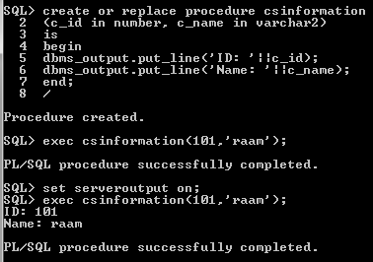

**Sample program for only function:**

**SQL>create or replace function csinformation**

**(h_id in number,c_name in varchar2)**

**Return varchar2**

**Is**

**Begin**

**If c_id>200 then**

**Return(‘no booking available’);**

**Else**

**Return(‘booking open’);**

**End if;**

**End;**

/

Function created.

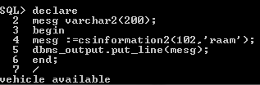

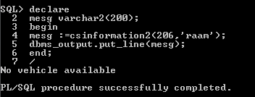

**TASK 7**

**Sample program for only Loops**

* To print prime number customer id using loops

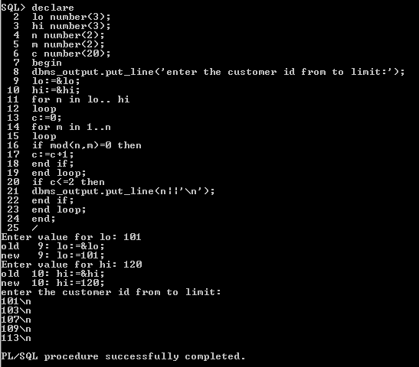

* To check the given customer booking number is Armstrong number.

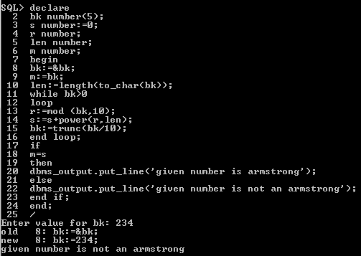

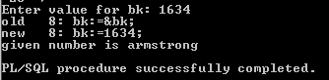

**TASK 8: Normalizing databases using functional dependencies upto BCNF**

**(Tool: GU/ Table Normalization Tool, ALM:Jigsaw) CO3, K3**

Upon relational tables created in task-2, perform normalization up to BCNF based on given Dependencies as following for the assumed relations specified below.

Employee Database:

1. Identify employee attributes: Employee_ID, Name, Department, Job_Title, Manager_ID, Hire_Date, Salary.

2. Define relational schema: Employee (Employee_ID, Name, Department, Job_Title, Manager_ID, Hire_Date, Salary).

3. Determine functional dependencies (FDs) between attributes:

- Employee_ID -> Name, Department, Job_Title, Manager_ID, Hire_Date, Salary

- Department -> Manager_ID

- Manager_ID -> Name

Step 2: Convert to 1NF

1. Eliminate repeating groups or arrays (none in this example).

2. Create separate tables for each repeating group (none in this example).

Step 3: Convert to 2NF

1. Ensure each non-key attribute depends on the entire primary key.

2. Move non-key attributes to separate tables if they depend on only part of the primary key.

- Create Department table: Department (Department_ID, Manager_ID, Name).

- Create Employee table: Employee (Employee_ID, Name, Department_ID, Job_Title, Hire_Date, Salary).

Step 4: Convert to 3NF

1. Ensure there are no transitive dependencies.

2. Move non-key attributes to separate tables if they depend on another non-key attribute.

- Create Manager table: Manager (Manager_ID, Name).

- Update Department table: Department (Department_ID, Manager_ID).

Step 5: Convert to BCNF

1. Ensure every determinant is a candidate key.

2. Check for overlapping candidate keys.

3. Decompose relations to eliminate redundancy.

- No further decomposition needed.

**Using Griffith Tool**

1. Input relational schema and functional dependencies.

2. Griffith tool generates a dependency graph.

3. Analyze the graph to identify normalization issues.

4. Apply normalization rules to transform the schema.

5. Verify the resulting schema meets BCNF criteria.

**Griffith Tool Steps**

1. Create a new project in Griffith.

2. Define the relational schema and FDs.

3. Run the "Dependency Graph" tool.

4. Analyze the graph for normalization issues.

5. Apply transformations using the "Normalize" tool.

6. Verify BCNF compliance using the "BCNF Check" tool.

**Normalized Schema**

1. Employee (Employee_ID, Name, Department_ID, Job_Title, Hire_Date, Salary).

2. Department (Department_ID, Manager_ID).

3. Manager (Manager_ID, Name).

**TASK 9: Backing up and recovery in databases CO4, K3**

Perform following backup and recovery scenarios.

1. Recovering a NOARCHIVELOG Database with Incremental Backups
2. Restoring the Server Parameter File
3. Performing Recovery with a Backup Control File

**Scenario 1: Recovering a NOARCHIVELOG Database with Incremental Backups**

-- Step 1: Backup Database

BACKUP DATABASE [database_name] TO DISK = 'backup_file.bak' WITH NOFORMAT, NOINIT, NAME = 'Full Database Backup', SKIP, REWIND, NOUNLOAD, STATS = 10

-- Step 2: Create Incremental Backup

BACKUP DATABASE [database_name] TO DISK = 'incremental_backup.bak' WITH DIFFERENTIAL, NOFORMAT, NOINIT, NAME = 'Incremental Database Backup', SKIP, REWIND, NOUNLOAD, STATS = 10

-- Step 3: Simulate Data Loss

-- Intentionally delete or modify data.

-- Step 4: Restore Database

RESTORE DATABASE [database_name] FROM DISK = 'backup_file.bak' WITH REPLACE

-- Step 5: Apply Incremental Backup

RESTORE DATABASE [database_name] FROM DISK = 'incremental_backup.bak' WITH REPLACE

-- Step 6: Recover Database

RECOVER DATABASE [database_name]

-- Step 7: Open Database

ALTER DATABASE [database_name] SET ONLINE

**Scenario 2: Restoring the Server Parameter File (SPFILE)**

-- Step 1: Backup SPFILE

BACKUP SERVER PARAMETER FILE TO FILE = 'spfile.bak';

-- Step 2: Simulate SPFILE Loss

-- Delete or modify SPFILE.

-- Step 3: Restore SPFILE

STARTUP MOUNT

RESTORE SERVER PARAMETER FILE FROM FILE = 'spfile.bak';

SHUTDOWN

STARTUP

**Scenario 3: Performing Recovery with a Backup Control File**

-- Step 1: Backup Control File

BACKUP CONTROLFILE TO FILE = 'controlfile.bak';

-- Step 2: Simulate Control File Loss

-- Delete or modify control file.

-- Step 3: Restore Control File

STARTUP MOUNT

RESTORE CONTROLFILE FROM FILE = 'controlfile.bak';

ALTER CONTROLFILE REUSE;

-- Step 4: Recover Database

RECOVER DATABASE USING BACKUP CONTROLFILE;

-- Step 5: Open Database

ALTER DATABASE OPEN RESETLOGS;

SQL Server Commands:

- BACKUP DATABASE

- RESTORE DATABASE

- RECOVER DATABASE

- ALTER DATABASE

- BACKUP SERVER PARAMETER FILE

- RESTORE SERVER PARAMETER FILE

- BACKUP CONTROLFILE

- RESTORE CONTROLFILE

**Result:**

**TASK 10- CRUD OPERATIONS IN DOCUMENT DATABASES**

**AIM:**

To Perform Mongoose using NPM design on MongoDB designing document database and performing CRUD operations like creating, inserting, querying, finding and removing operations.

**STEPS:**

Step 1)install Mongo db using following link

<https://www.mongodb.com/try/download/community>

Step 2)install Mongosh using the below link

<https://www.mongodb.com/docs/mongodb-shell/#download-and-install-mongosh>

Step 3)To add the MongoDB Shell binary's location to your PATH environment variable:

Open the Control Panel.

In the System and Security category, click System.

Click Advanced system settings. The System Properties modal displays.

Click Environment Variables.

In the System variables section, select path and click Edit. The Edit environment variable modal displays.

Click New and add the filepath to your mongosh binary.

Click OK to confirm your changes. On each other modal, click OK to confirm your changes.

To confirm that your PATH environment variable is correctly configured to find mongosh, open a command prompt and enter the mongosh --help command.

If your PATH is configured correctly, a list of valid commands displays.

Step 4)Open mongo shell 4.0 from c:\programfiles\mongoDB\server\bin\mongod.exe

Step 5)Type the CRUD(CREATE READ UPDATE DELETE) COMMANDS GIVEN IN TEXT FILE.

**CRUD OPERATIONS**

db.createCollection("mylab")

{ "ok" : 1 }

> db.mylab.insertOne({item:"canvas",qty:100,tags:["cotton"],size:{h:28,w:35.5,uom:"cm"}})

{

"acknowledged" : true,

"insertedId" : ObjectId("627d13acc73990c074e6397c")

}

> db.mylab.find({item:"canvas"})

{ "_id" : ObjectId("627d13acc73990c074e6397c"), "item" : "canvas", "qty" : 100, "tags" : [ "cotton" ], "size" : { "h" : 28, "w" : 35.5, "uom" : "cm" } }

> db.mylab.insertMany([{item:"journal",qty:25,tags:["blank","red"],size:{h:14,w:21,uom:"cm"}},{item:"mat",qty:85,tags:["gray"],size:{h:27.9,w:35.5,uom:"cm"}},{item:"mousepad",qty:25,tags:["gel","blue"],size:{h:19,w:22.85,uom:"cm"}}])

{

"acknowledged" : true,

"insertedIds" : [

ObjectId("627d1598c73990c074e6397d"),

ObjectId("627d1598c73990c074e6397e"),

ObjectId("627d1598c73990c074e6397f")

]

}

> db.mylab.find({},{item:1,qty:1})

{ "_id" : ObjectId("627d13acc73990c074e6397c"), "item" : "canvas", "qty" : 100 }

{ "_id" : ObjectId("627d1598c73990c074e6397d"), "item" : "journal", "qty" : 25 }

{ "_id" : ObjectId("627d1598c73990c074e6397e"), "item" : "mat", "qty" : 85 }

{ "_id" : ObjectId("627d1598c73990c074e6397f"), "item" : "mousepad", "qty" : 25 }

> db.mylab.find({},{item:1,qty:1}).pretty()

{

"_id" : ObjectId("627d13acc73990c074e6397c"),

"item" : "canvas",

"qty" : 100

}

{

"_id" : ObjectId("627d1598c73990c074e6397d"),

"item" : "journal",

"qty" : 25

}

{ "_id" : ObjectId("627d1598c73990c074e6397e"), "item" : "mat", "qty" : 85 }

{

"_id" : ObjectId("627d1598c73990c074e6397f"),

"item" : "mousepad",

"qty" : 25

}

> db.mylab.find({item:"canvas"}).pretty().sort({item:-1})

{

"_id" : ObjectId("627d13acc73990c074e6397c"),

"item" : "canvas",

"qty" : 100,

"tags" : [

"cotton"

],

"size" : {

"h" : 28,

"w" : 35.5,

"uom" : "cm"

}

}

> db.mylab.deleteOne({item:"journal"}

...

...

> db.mylab.find({},{item:1,qty:1}).pretty()

{

"_id" : ObjectId("627d13acc73990c074e6397c"),

"item" : "canvas",

"qty" : 100

}

{

"_id" : ObjectId("627d1598c73990c074e6397d"),

"item" : "journal",

"qty" : 25

}

{ "_id" : ObjectId("627d1598c73990c074e6397e"), "item" : "mat", "qty" : 85 }

{

"_id" : ObjectId("627d1598c73990c074e6397f"),"item" : "mousepad","qty" : 25}

**Result:**

The implementation of CRUD operations like creating, inserting, finding and removing operations using MongoDB is successfully executed.

**TASK 11- CRUD OPERATIONS IN GRAPH DATABASES**

**AIM:**

To perform CRUD operations like creating, inserting, querying, finding, deleting operations on graph spaces.

* **Create Node with Properties**

Properties are the key-value pairs using which a node stores data. You can create a node with properties using the CREATE clause. You need to specify these properties separated by commas within the flower braces “{ }”.

**Syntax**

Following is the syntax to create a node with properties.

CREATE (node:label { key1: value, key2: value, . . . . . . . . . })

* **Returning the Created Node**

To verify the creation of the node, type and execute the following query in the dollar prompt.

MATCH (n) RETURN n

* **Creating Relationships**

We can create a relationship using the CREATE clause. We will specify relationship within the square braces “[ ]” depending on the direction of the relationship it is placed between hyphen “ - ” and arrow “ → ” as shown in the following syntax.

**Syntax**

Following is the syntax to create a relationship using the CREATE clause.

CREATE (node1)-[:RelationshipType]->(node2)

* **Creating a Relationship Between the Existing Nodes**

You can also create a relationship between the existing nodes using the MATCH clause.

**Syntax**

Following is the syntax to create a relationship using the MATCH clause.

MATCH (a:LabeofNode1), (b:LabeofNode2)

WHERE a.name = "nameofnode1" AND b.name = " nameofnode2"

CREATE (a)-[: Relation]->(b)

RETURN a,b

* **Deleting a Particular Node**

To delete a particular node, you need to specify the details of the node in the place of “n” in the above query.

**Syntax**

Following is the syntax to delete a particular node from Neo4j using the DELETE clause.

MATCH (node:label {properties . . . . . . . . . . })

DETACH DELETE node

**Create a graph database for student course registration, create student and dept node and insert values of properties.**

create(n:student{Sid: "VTU14500",

Sname:"John",

deptname:"CSE" }

)

**OUTPUT**

Added 1 label, created 1 node, set 3 properties, completed after 232 ms.

Create(n:student {Sid: "VTU14501",

Sname:"Dharsana",

deptname:"EEE"})

**OUTPUT**

Added 1 label, created 1 node, set 3 properties, completed after 16 ms.

Create(w:student { Sid: "VTU14502",

Sname:"vijay",

deptname:"CSE"

})

**OUTPUT**

Added 1 label, created 1 node, set 3 properties, completed after 12 ms.

Create(n:dept{deptname:"cse",deptid:"d001"})

**OUTPUT:**

Added 1 label, created 1 node, set 2 properties, completed after 72 ms.

**Select all the nodes in your database using match command**

* **match(n) return(n)**

**OUTPUT**

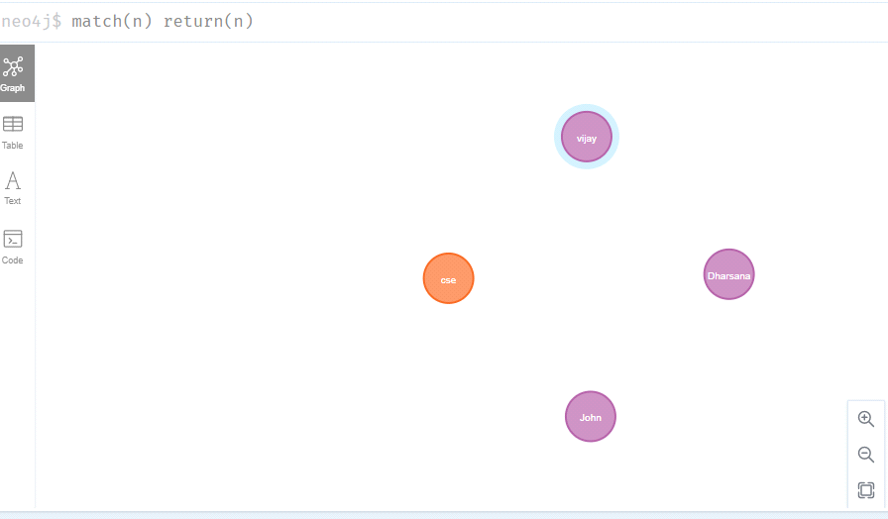

* **match(n:student) return(n)**

**OUTPUT:**

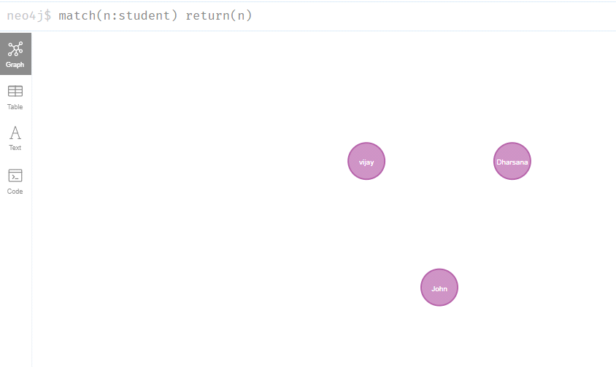

1. **Create relationship between student and cse** .

MATCH(s:student),(d:dept) WHERE s.Sname ='vijay' AND d.deptname='cse'

CREATE(s)-[st:STUDIED_AT]->(d)

return s,d

**OUTPUT:**

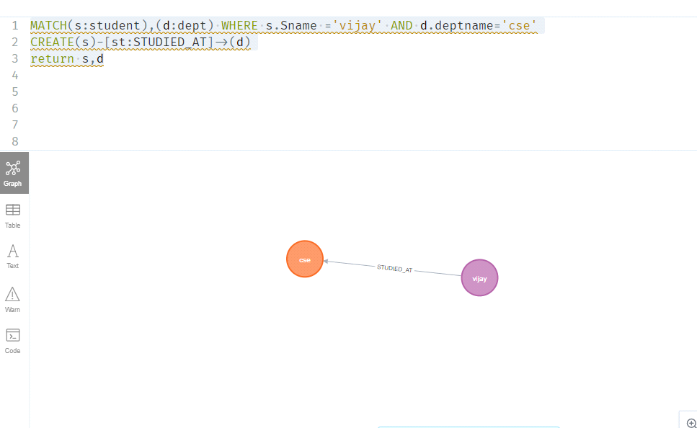

MATCH(s:student),(d:dept) WHERE s.Sname ='John' AND d.deptname='cse'

CREATE(s)-[st:STUDIED_AT]->(d)

return s,d

OUTPUT:

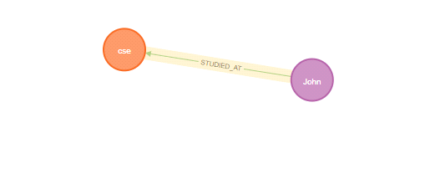

**match(n) return(n)**

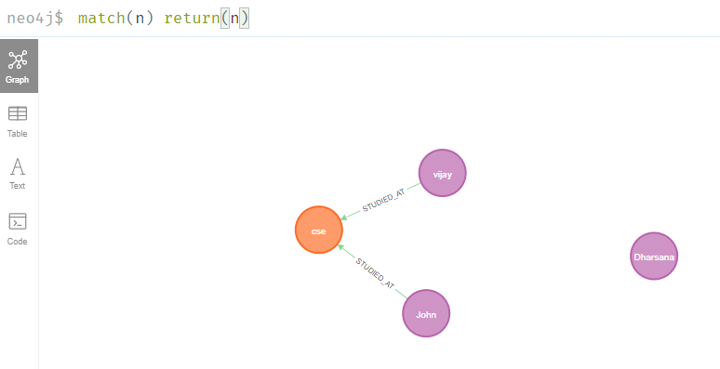

1. **Delete a node from student**

match(n:student{Sname:'Dharsana'}) DELETE(n)

**OUTPUT:**

Deleted 1 node, complaeted after 10834 ms.

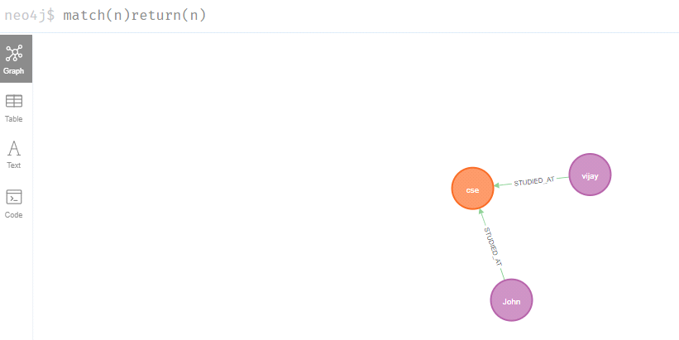

**Result**

The implementation of CRUD operations like creating, inserting, finding and removing operations using GraphDB is successfully executed.

**TASK 12: MINI PROJECT**

**TITLE :AIRLINE MANAGEMENT SYSTEM**

**1.ER DIAGRAM:**

**AIM:** To draw the conceptual design for airline management system

**E-R DIAGRAM:**

**ENTITIY_RELATIONAL MODEL:**

**→** ER model stands for an Entity-Relationalship Model .It is a highlevel data Model. This Model is Used to define the data elements and relationalshipFor a specified system.

→It develops a conceptual design for the database .It also develops a very Simple and easy to design view of data.

→ It develops a conceptual design for the database .It also develops a very Simple and easy to design view of data

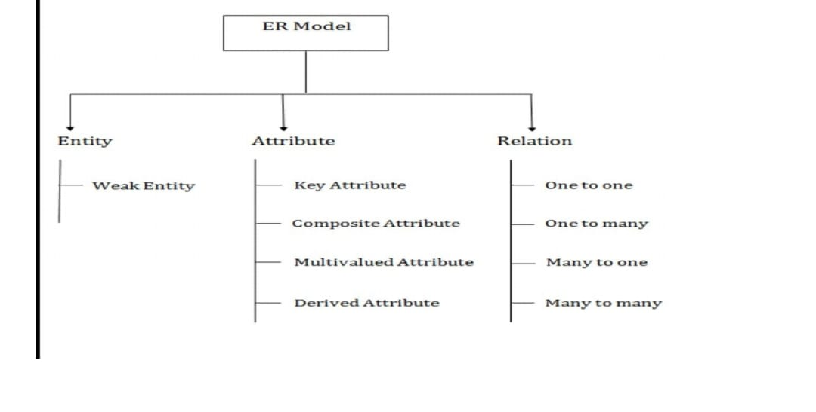

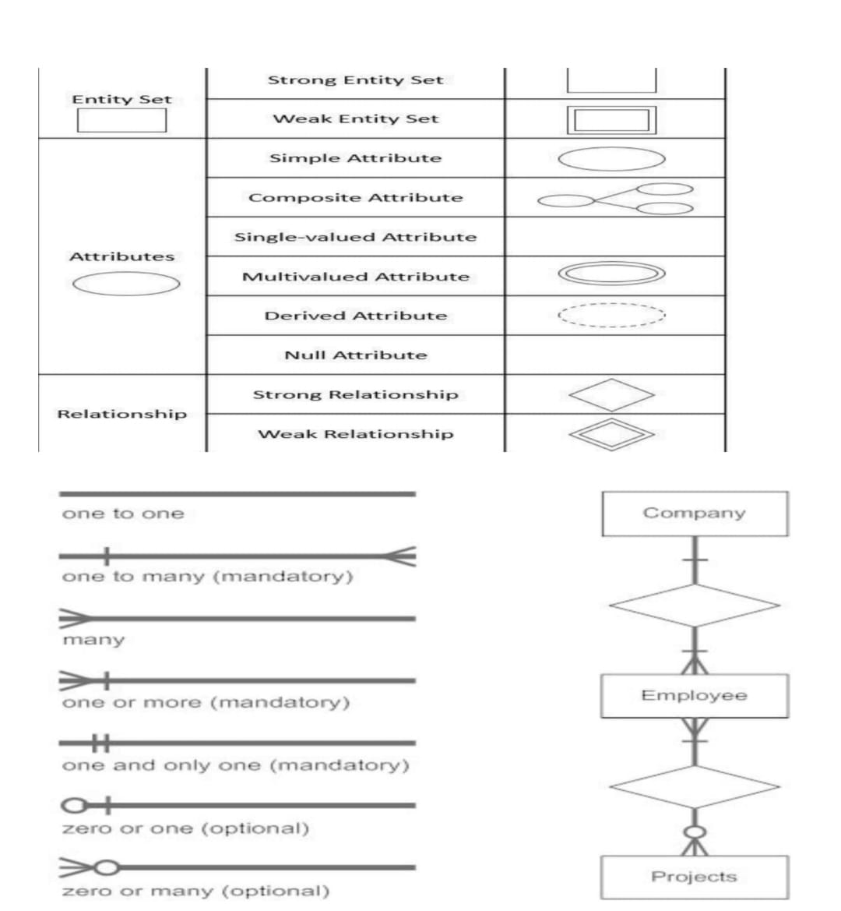

**WEAK ENTITY:** An entity that depends on another entity called a weak entity.

The weak entity does not contain any key attributes of its own. The weak entity is

Represented by a double rectangle.

**ATTRIBUTES**:The attribute is used to describe the property of an entity .Eclipse is

Used to represent an attribute.

**KEY ATTRIBUTES:** The key attribute is used to represent the main characteristics

Of an entity . It represents a primary key. The attribute is represented by an

Ellipse with the text underlined.

**COMPOSITE ATTRIBUTES:** An attribute that composed of many other attributes is

Known as a composite attribute. The composite attribute is represented by an

Ellipse , and those ellipse are connected with an ellipse.

**MULTIVALUED ATTRIBUTES :** An attribute can have more than one value .These

Attributes are known as a multivalued attribute. The double oval is used to

Represent multivalued attribute.

**DERIVED ATTRIBUTES** : Attributes which are derived from other attributes.

**ER-MODEL FOR AIRLINE MANAGEMENT SYSTEM**

**ENTITIES :** Airline , Passenger , Flight ,Route , Employees , Ticket Booking**.**

**ATTRIBUTES:**

→Airline: airline_id , icao_code , iata_code , name.

→Aircraft: aircraft_id ,model, capacity , airline_id.

→Flight: flight_id , flight_number , departure_time , arrival_time,status.

→Route:route_id,source_airport_id,destination_airport_id,distance.

→Airport : airport_id , name , code , location.

→Passenger : passenger_id , first_name , last_name , email.

→Employees : employee_id , name.

→Ticket booking : booking_id , status , booking_date , flight _id , passenger_id.

**RELATIONS:**

Airline uses aircraft

Airline operates flight

Airport located at route

Employees assigned to flight

Passenger books ticket booking

Ticket booking has flight

Flight has route

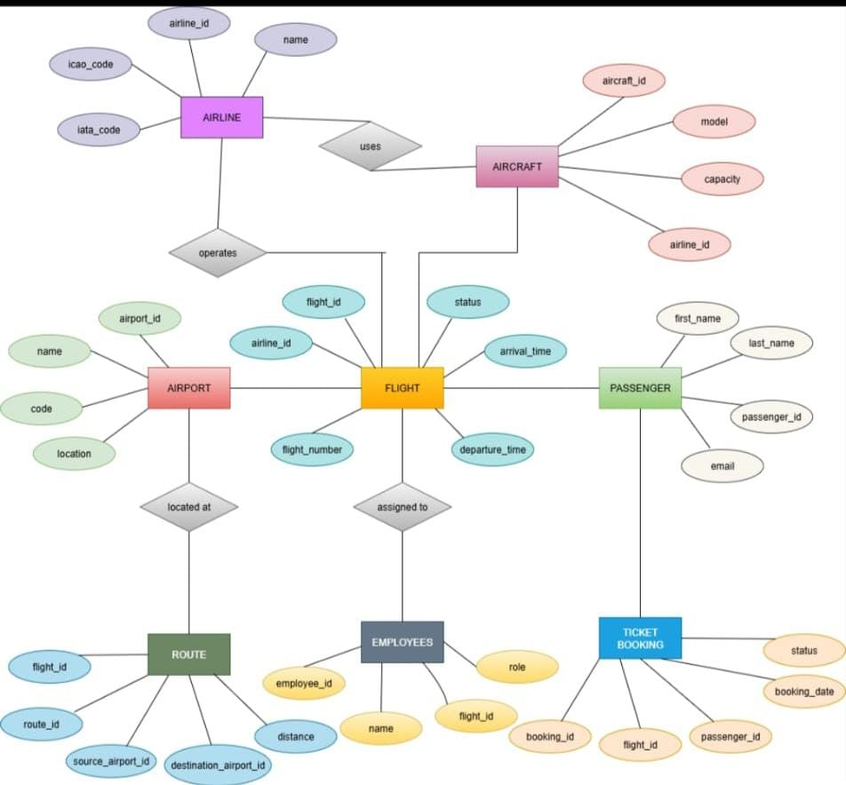

**RESULT:** Thus, the creating er diagram is completed successfully.

**AIM :** To excute relational operations ,SQL,aggregates,Joint queries for library

Management system.

Relational operations:

Create table :

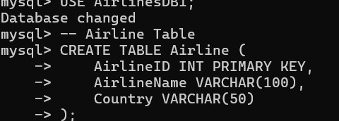

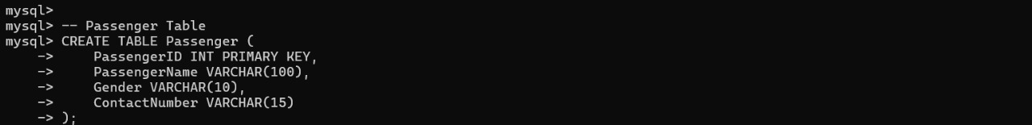

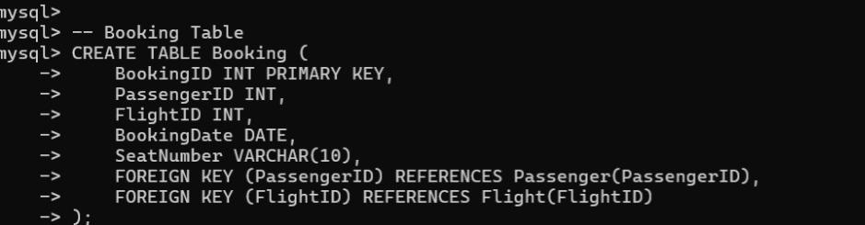

Inserting elements:

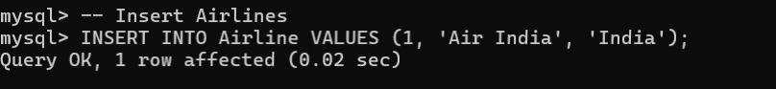

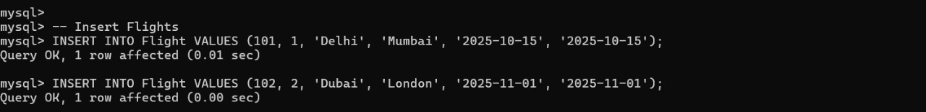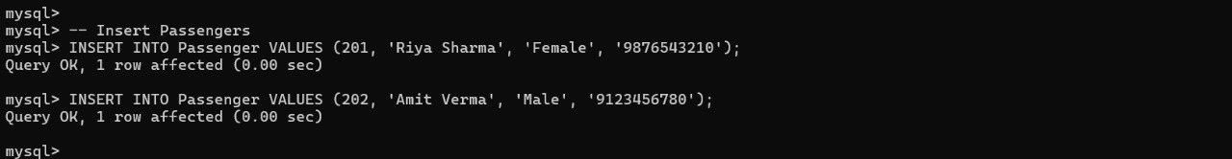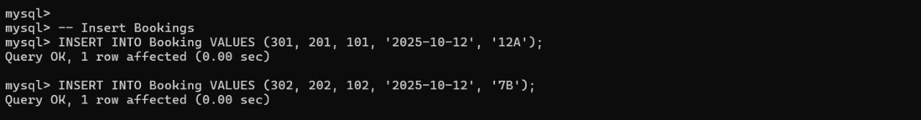Alter operation :

Update:



Delete:

Drop:

Rename:

Truncate:

Select:

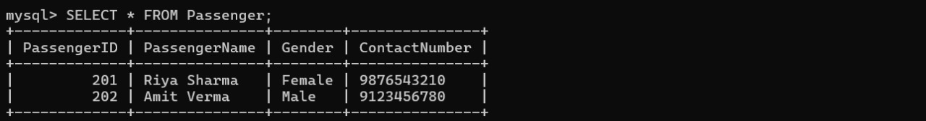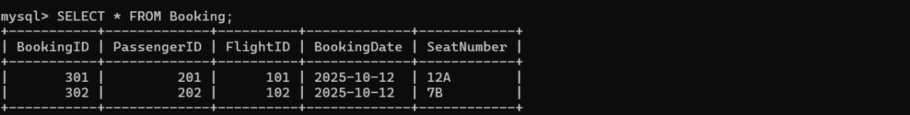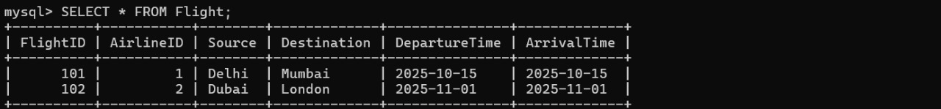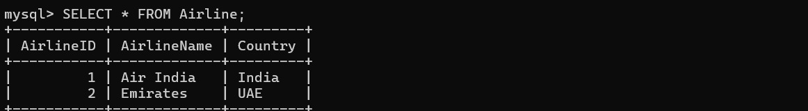

Aggregate functions:

Count:

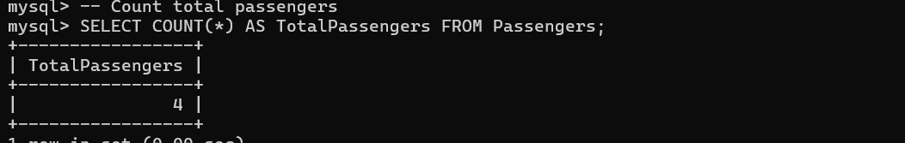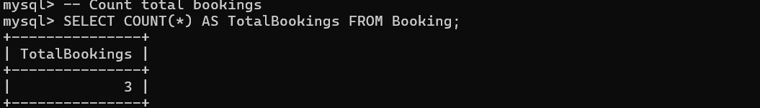

Sum:

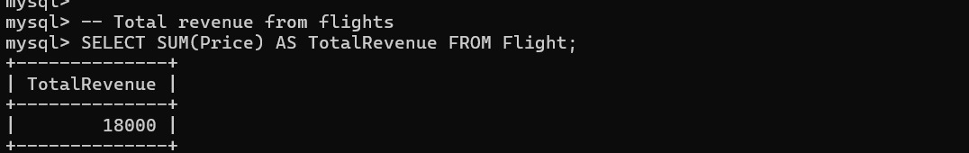Average:

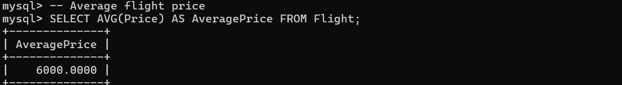

Minimum:

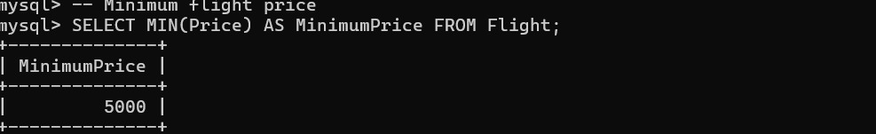

Maximum:

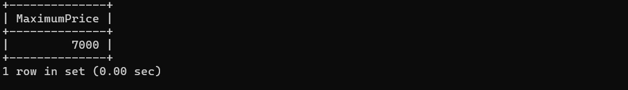

Join:

Inner join:

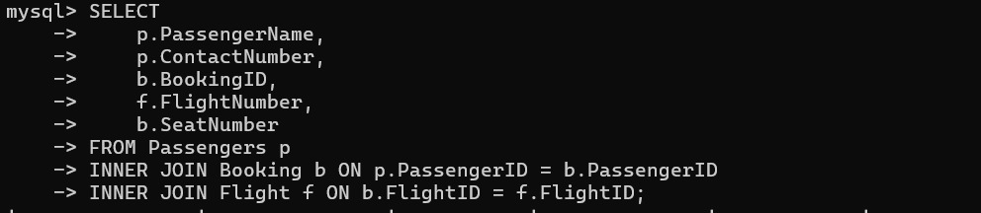left join:

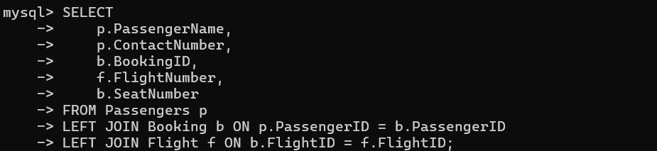

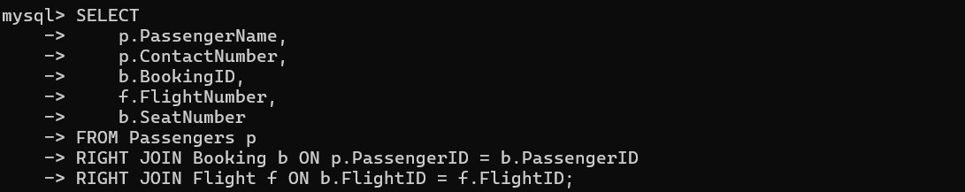Right join:

Result : Thus, to execute relational operations ,SQL, aggregate functions,join queries for airline management system is successfully executed.

NORMALIZATION

Normalization in the context of databases refers to the process of organizing data in a Database efficiently . The goal is to reduce data redundancy and dependency by organizing fields and table of a database . This helps in minimizing the anomalises that can arise when modifying the data

There are several normal forms(NF) that define the levels of normalization , with each form addressing different types of issues.

First Normal Form:

→eliminate duplicate columns from the same table .

→create a separate table for each group of related data and identity each row with a unique column or set of columns.

Second Normal Form:

→meet all the requirements of 1NF.

→remove partial dependencies -ensure that non-prime attributes are fully functionally dependent on the primary dependent on the primary key.

Boyce-Codd Normal Form:

→A more stringent form form of 3NF.

→For a table to be in a BCNF, it must satisfy an additional requirement compared to 3NF ,dealing specifically with certain types of functional dependencies

→ we use Griffith university normalization tool in web browser.

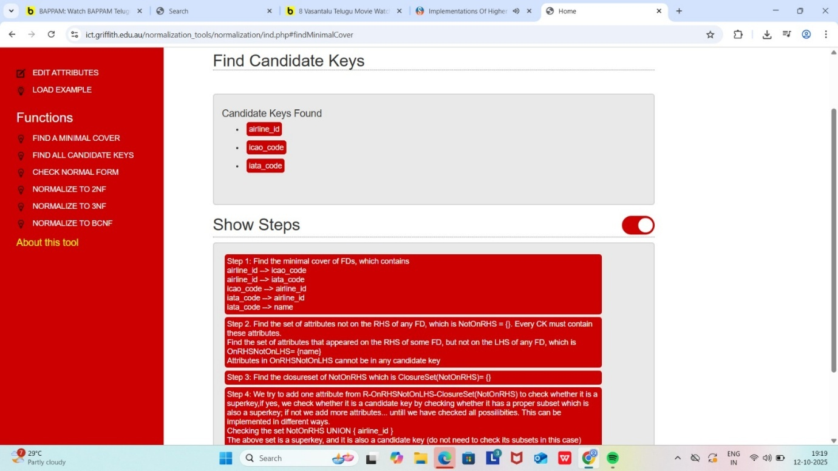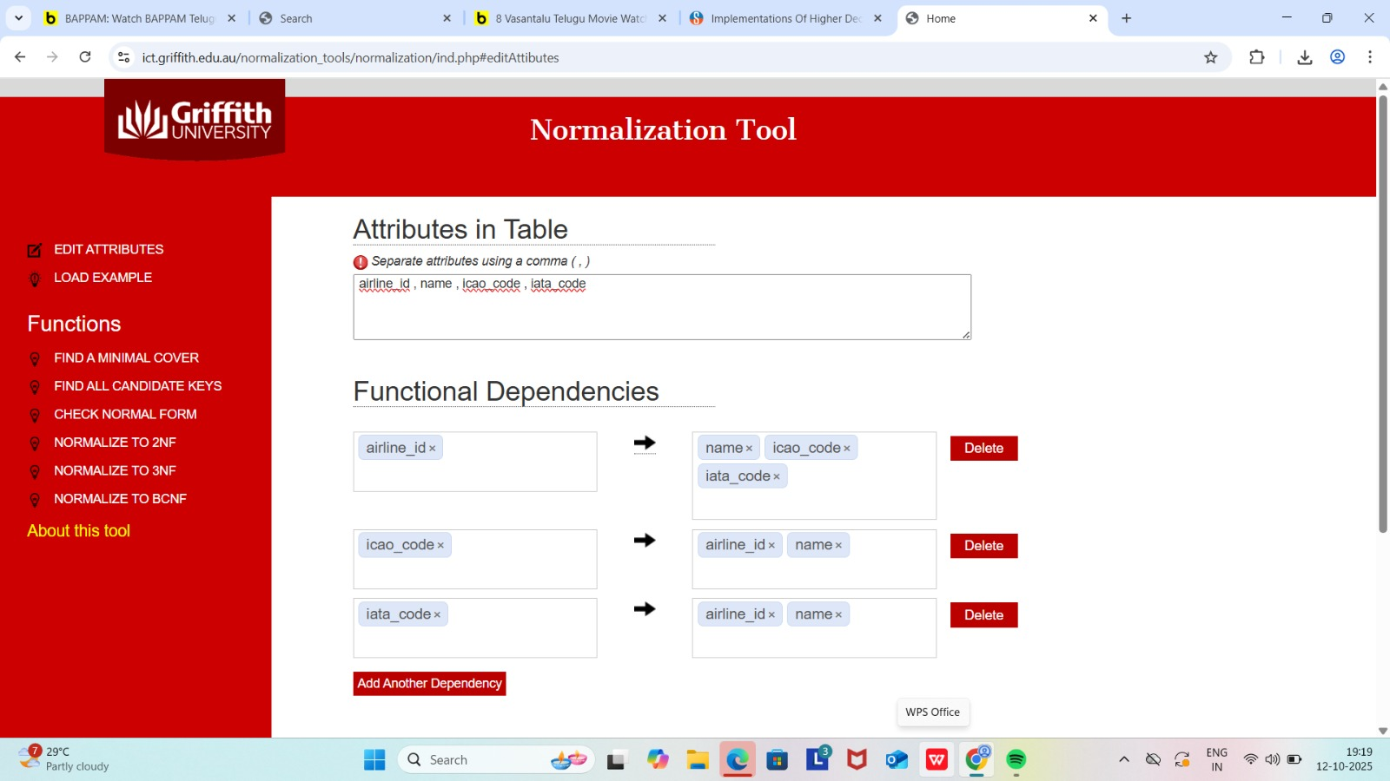

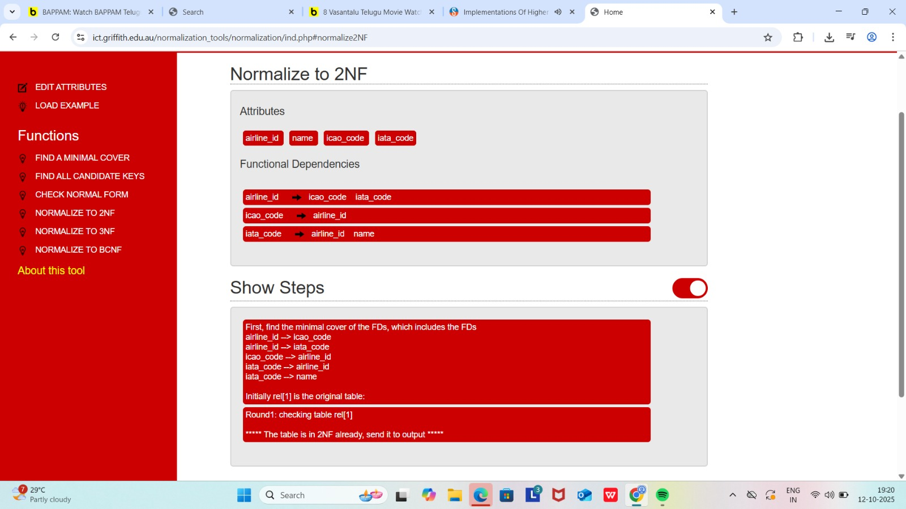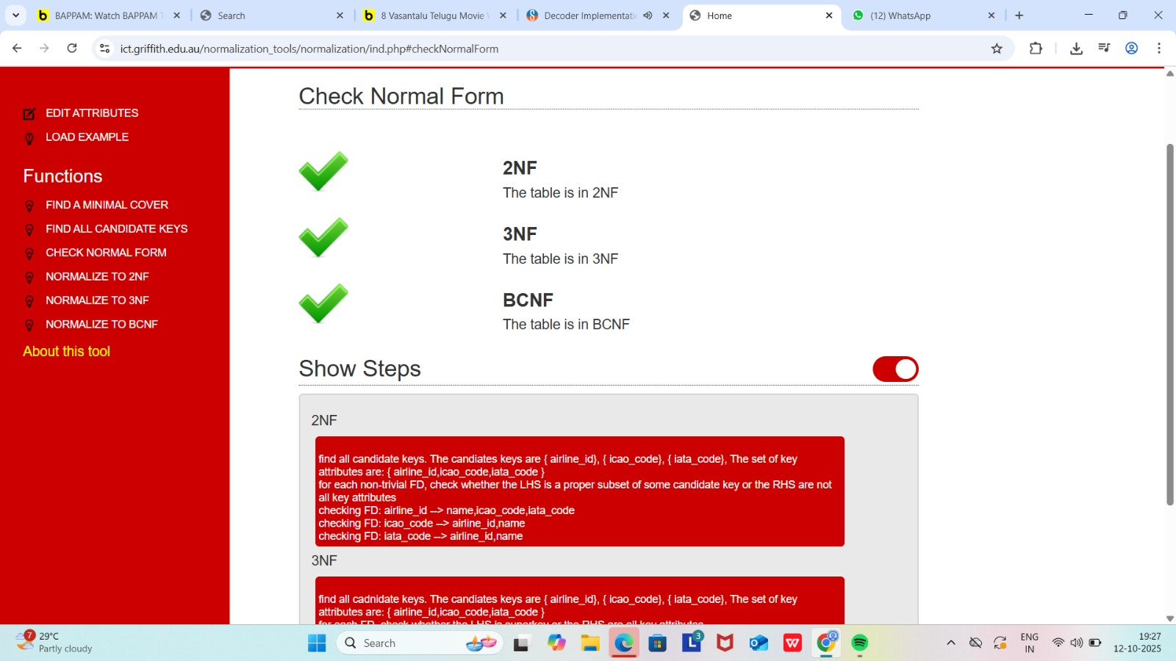

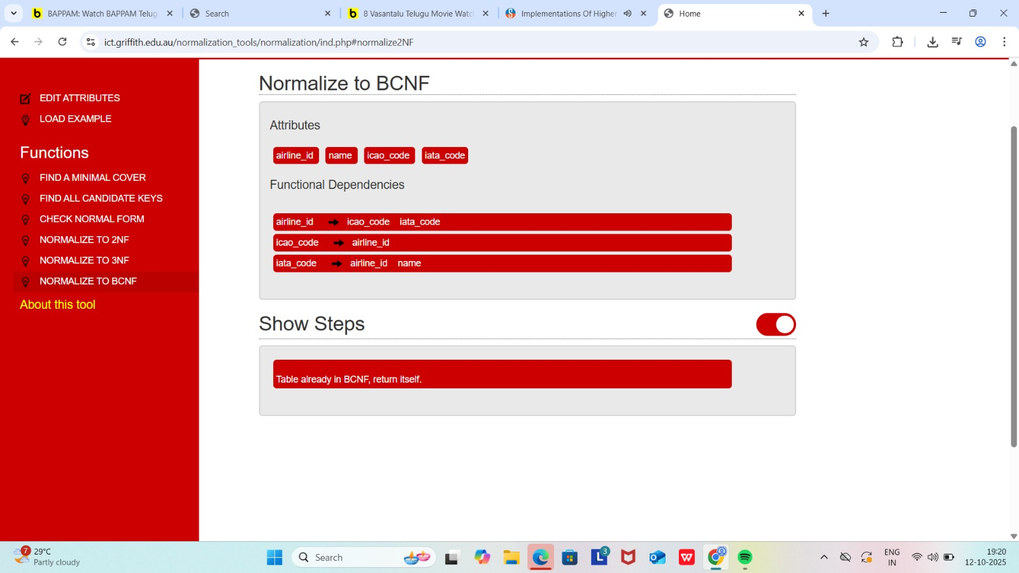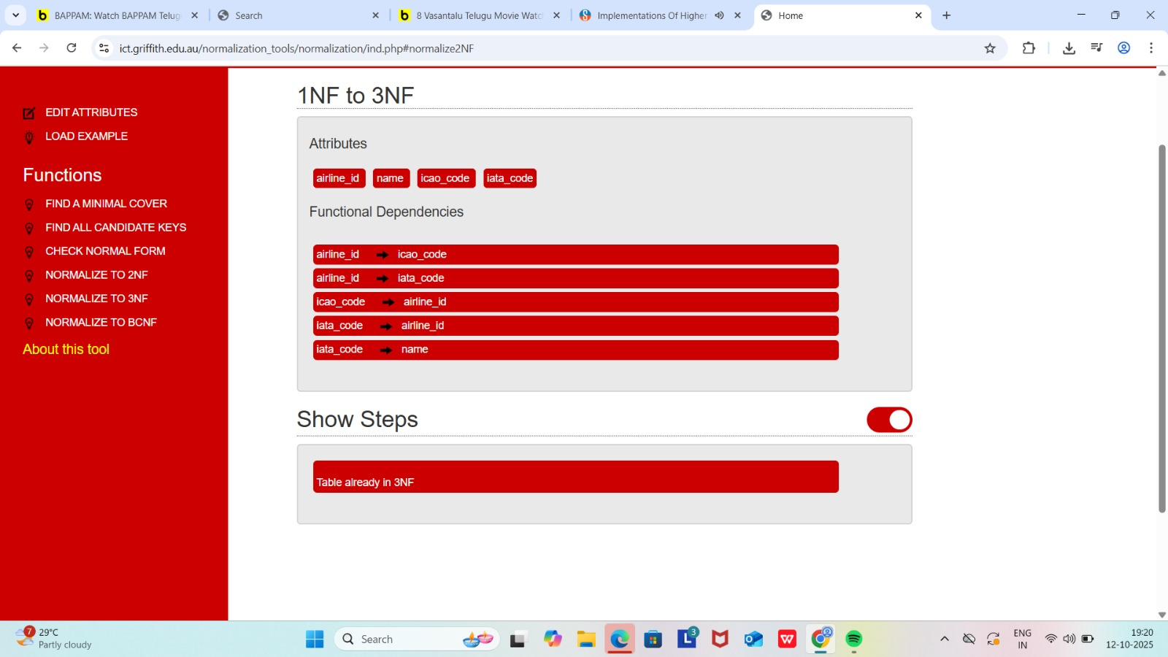

RESULT: Thus , the normalization to 1nf, 2nf , 3nf, BCNF is completed successfully.

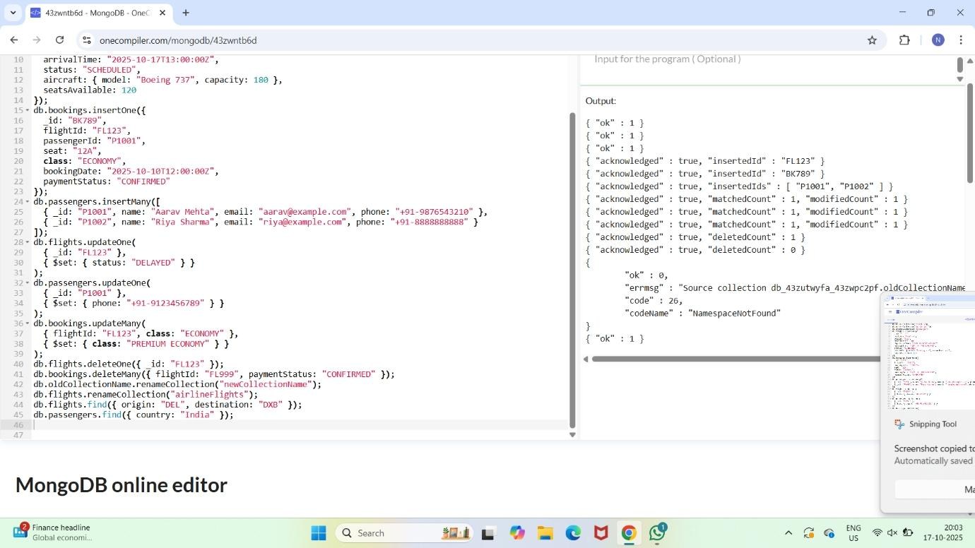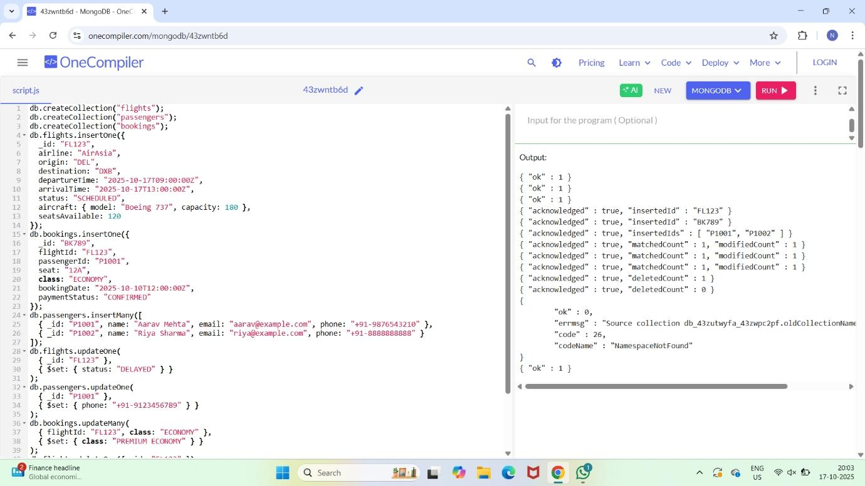AIM: to implement the document database and graph database by using mongosh.

Result: Thus implelemented the document database and graph database by using mon gosh.